3/1/2016
Jomin Kaitholil George

CSC3122 – Mobile Computer Systems Development
Font Board

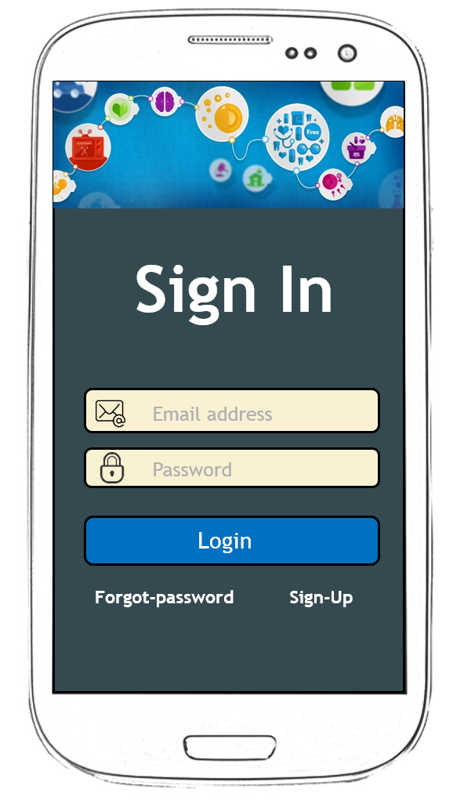
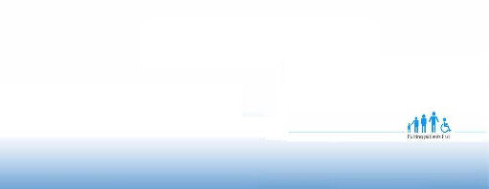









- Header
  - Trebuchet MS (Body)
  - Size 10

- Body
  - Trebuchet MS (Body)
  - Size 7

Profile
Find Services
Remainder
Appointments
Call for help
Useful Links
Send Feedback
About the app
Home

- Header
  - Comic Sans MS
  - Size 11

- Body
  - Verdana Pro Light
  - Size 5

Profile
Find Services
Remainder
Appointments
Call for help
Useful Links
Send Feedback
About the app
Home

Profile
Find Services
Remainder
Appointments
Call for help
Useful Links
Send Feedback
About the app
Home

- Header
  - Tahoma
  - Size 10 and Bold

- Body
  - Tahoma
  - Size 7 and Italic

Profile
Find Services
Remainder
Appointments
Call for help
Useful Links
Send Feedback
About the app
Profile
Find Services
Remainder
Appointments
Call for help
Useful Links
Send Feedback
About the app

Home
About the app
Send Feedback
Useful Links
Call for help
Appointments
Remainder
Find Services
Profile




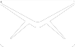

- Text fields

Profile
Language
Gender
Contact Number
Email Address
Done
Change Picture
Last Login: Thursday, February 29, 2016, 15:20:13
Jomin George
Profile
Language
Gender
Contact Number
Email Address
Done
Change Picture
Last Login: Thursday, February 29, 2016, 15:20:13
Jomin George


Call 999
Call 999
Call 999
- Buttons

Call for help
NHS provide two different helpline for the patient, 111 service is free telephone service which a team of fully trained advisers there to assist you 24 hours a day, 365 days a year.
999 is an emergency number and only ring this number if you or the patient you ringing for is seeking for urgent care
Call 111
Call 999
Call for help
NHS provide two different helpline for the patient, 111 service is free telephone service which a team of fully trained advisers there to assist you 24 hours a day, 365 days a year.
999 is an emergency number and only ring this number if you or the patient you ringing for is seeking for urgent care
Call 111

